How to complete commercial invoice to Konan Medical
1. Date - The date of when the shipment was created.
2. Invoice Number - Add the number of the invoice or RMA that is associated with the shipment.
3. Sender - Add the information for the company that will be shipping the product to Konan. This should include the contact’s name, telephone number, and e-mail address. This should also include the business name, full address, and any special instructions for finding or entering the business. Also include the company’s Country Tax Identification number.
4. Exporter of Record (EoR) - This is only to be filled out if the sender and EoR are different entities. Add the information for the company that will be responsible for the exportation of products to Konan/consignee. This should include the contact’s name, telephone number, and e-mail address. This should also include the business name, full address, and any special instructions for finding or entering the business. Also include the company’s Country Tax Identification number.
5. Consignee - Include all the information for the consignee/receiver of the shipment. You will need to include the contact’s name and telephone number. You will also need to include the company’s name, full address, and any special instructions needed to deliver the product to the correct area.
6. Quantity - Add the quantity for each line item that you are sending.
7. Country of Origin - Add the country where the product was manufactured here. This is the country where the final product was built not where the components were built.
8. Serial Number - Add the serial number of the product in this area.
9. Part Number - Add the inventory part number for the line item.
10. Description - Add the part number description as it shows up on the SO/RMA.
11. Unit Price - Add the sale price of each unit.
12. Total - Add the total price of the units sold.
13. Subtotal of Product Shipped - Add subtotal for all items that are shipping on this CI.
14. Shipping - Add cost of shipping the product.
15. Total - Add the subtotal and shipping costs and add combined total here.
16. INCO Terms - Add your appropriate International Commercial Terms (INCO Term).
17. HTS - Add Harmonized Tariff Schedule.
18. Shipper Name - Add shipper’s contact name and their signature is placed on the line above.
19. Date - Add date the commercial invoice was signed.
20. Shipper Title - Add the job title of the shipper’s contact.
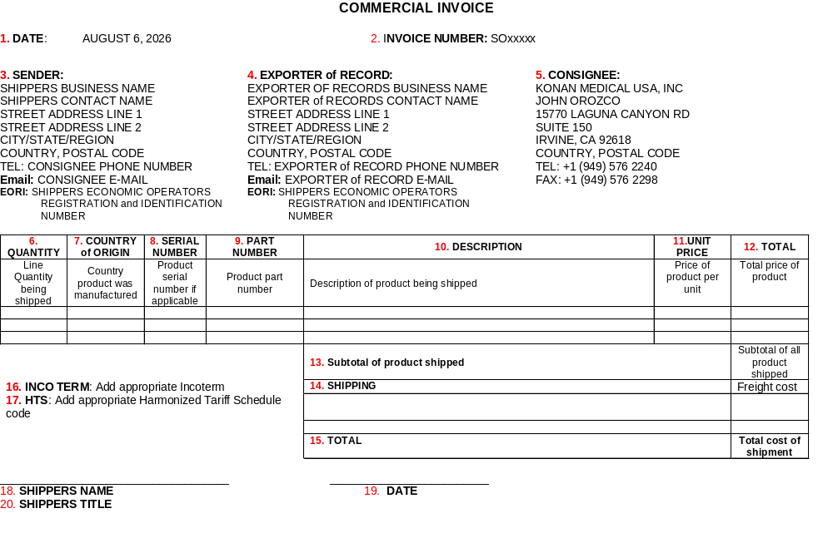
How to complete commercial invoice to your business
1. Date - The date of when the shipment was created.
2. Invoice Number - Add the number of the invoice or RMA that is associated with the shipment.
3. Sender - Add the information for the company that will be shipping the product to Konan. This should include the contact’s name, telephone number, and e-mail address. This should also include the business name, full address, and any special instructions for finding or entering the business. Also include the company’s Country Tax Identification number.
4. Importer of Record (IoR) - This is only to be filled out if the consignee and IoR are different entities. Add the information for the company that will be responsible for the exportation of products to Konan. This should include the contact’s name, telephone number, and e-mail address. This should also include the business name, full address, and any special instructions for finding or entering the business. Also include the company’s Country Tax Identification number.
5. Consignee - Include all the information for the consignee/receiver of the shipment. You will need to include the contact’s name and telephone number. You will also need to include the company’s name, full address, and any special instructions needed to deliver the product to the correct area.
6. Quantity - Add the quantity for each line item that you are sending.
7. Country of Origin - Add the country where the product was manufactured here. This is the country where the final product was built not where the components were built.
8. Serial Number - Add the serial number of the product in this area.
9. Part Number - Add the inventory part number for the line item.
10. Description - Add the part number description as it shows up on the SO/RMA.
11. Unit Price - Add the sale price of each unit.
12. Total - Add the total price of the units sold.
13. Subtotal of Product Shipped - Add subtotal for all items that are shipping on this CI.
14. Shipping - Add cost of shipping the product.
15. Total - Add the subtotal and shipping costs and add combined total here.
16. INCO Terms - Add your appropriate International Commercial Terms (INCO Term).
17. HTS - Add Harmonized Tariff Schedule.
18. Shipper Name - Add shipper’s contact name and their signature is placed on the line above.
19. Date - Add date the commercial invoice was signed.
20. Shipper Title - Add the job title of the shipper’s contact.
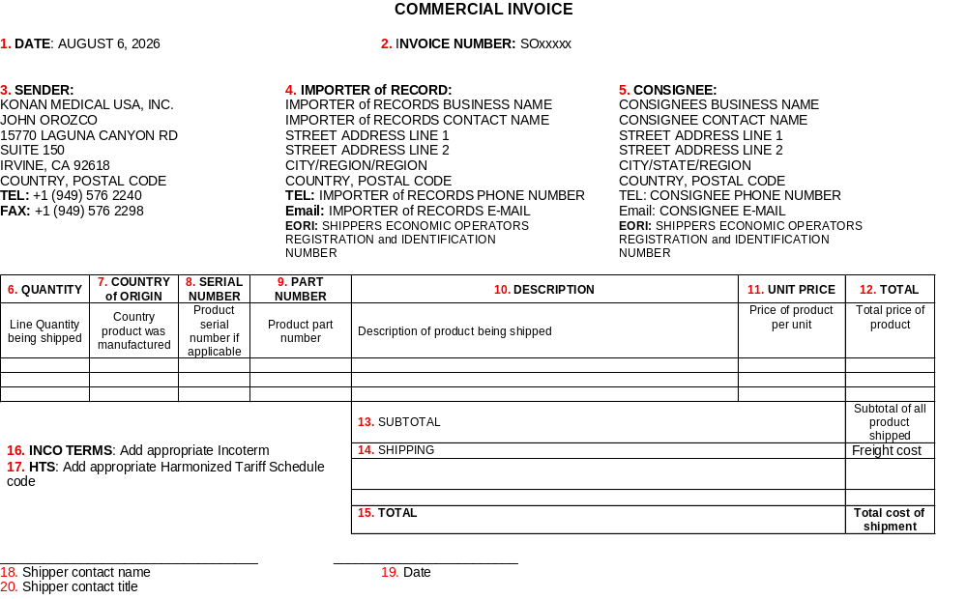
Definition of Shipping Terms
1. Invoice Number - A unique code or number that is assigned to a single bill or invoice.
2. Sender/Shipper - The person or company who sends a package or cargo.
3. Exporter of Record (EoR) - The legal entity responsible for making sure a shipment leaves a country in compliance with all export laws, rules, and customs regulations.
4. Consignee/Receiver - The person or business named on shipping paperwork that will receive the delivery.
5. Country of Origin (CoO) - This is the country where the end product was manufactured.
6. Serial Number - A unique code of numbers and/or letters given to a finished product as an identifier.
7. Part Number - A unique alphanumeric code assigned to specific components or items as identifiers.
8. Description - a short explanation of what the specific component/item is.
9. Unit Price - The cost for a single unit/product that is being purchased.
10. International Commerce Terms (INCO Terms) - 11 standardized rules created by ICC to define what the buyer and seller of a transaction is responsible for paying. INCO terms are 3 letter code that should be on every commercial invoice.
https://iccwbo.org/business-solutions/incoterms-rules/incoterms-2020/ 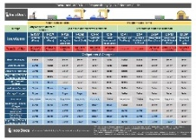
11. Harmonized Tariff Schedule (HTS) - This is a 10-digit number used to classify the physical goods that are being shipped internationally and are used to figure out the taxes and duties applied to the shipment.
https://hts.usitc.gov/

